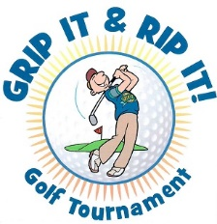

2022 Ag Aviation Golf Tournament
October 15 & 16, 2022
Red Apple Inn & Country Club, Heber Springs, Arkansas
Player Registration Form

Name: _____________________________________________________________________

Mailing Address: ____________________________________________________________

Phone: ____________________________________________________________________

Email: _____________________________________________________________________

Name of Golf Partner: ________________________________________________________

Name(s) of Any Additional Attendees: ___________________________________________

___________________________________________________________________________

FEES: Golf & Dinner $175.00 Per Person
Dinner Only $45.00 Per Person

Amount Enclosed:____________________________________________________________

THIS YEAR THE CHARITY DONATION WILL GO TO ST. JUDE HOSPITAL

Please make checks payable to Ag Aviation Golf Tournament and mail to:

Brenda Watts at 120 Norris Lane, Watson, AR 71674
Phone: 870-377-5241

