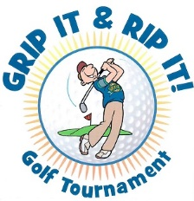
Ag Aviation Golf Tournament
October 15 & 16, 2022
Red Apple Inn & Country Club, Heber Springs, Arkansas

Sponsorship Registration:

Company Name___________________________________

Mailing Address___________________________________

Contact Person____________________________________

Phone___________________________

Email____________________________

Amount Enclosed_________________________

$250.00 Sponsorship with Name on a Tee Box
$100.00 Name on Banner and Acknowledgement
THIS YEAR THE CHARITY DONATION WILL GO TO ST. JUDE HOPITAL
Mail check to:
Brenda Watts, 120 Norris Lane, Watson, AR 71674
Phone: 870-377-5241

